Day in the Life of the Hudson River 10/13/22
USMA, West Point
RIVER MILE: 52
Salt Front: ~ RM76
USMA, West Point- MAJ Missy Moorehouse, 185 students & 88 adults
Latitude 41° 23’35.63’’ N & Longitude – 73°57’6.04’’W
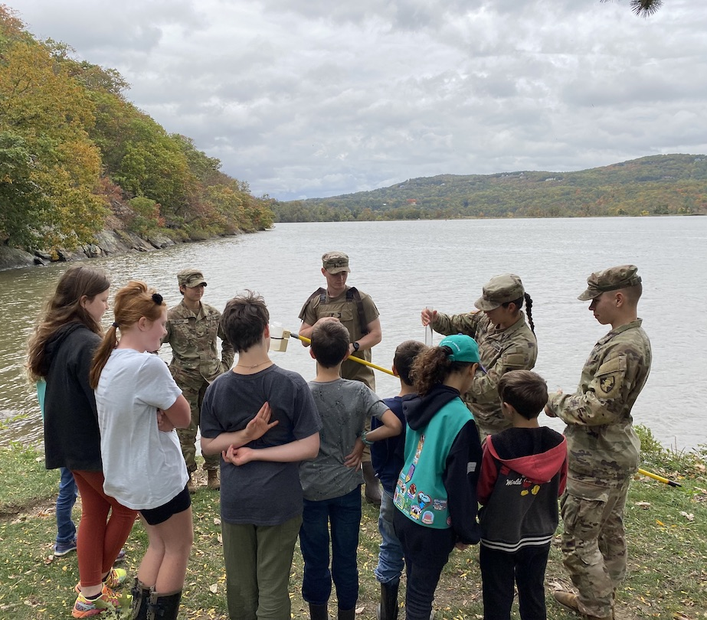 | 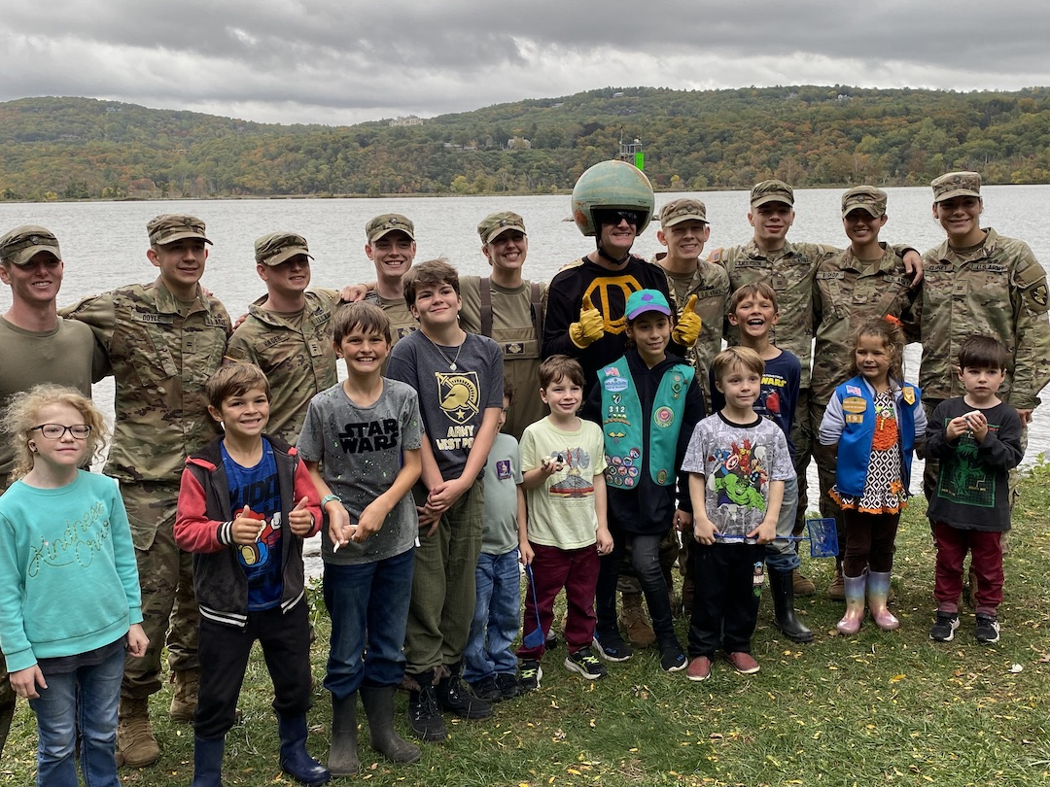 | 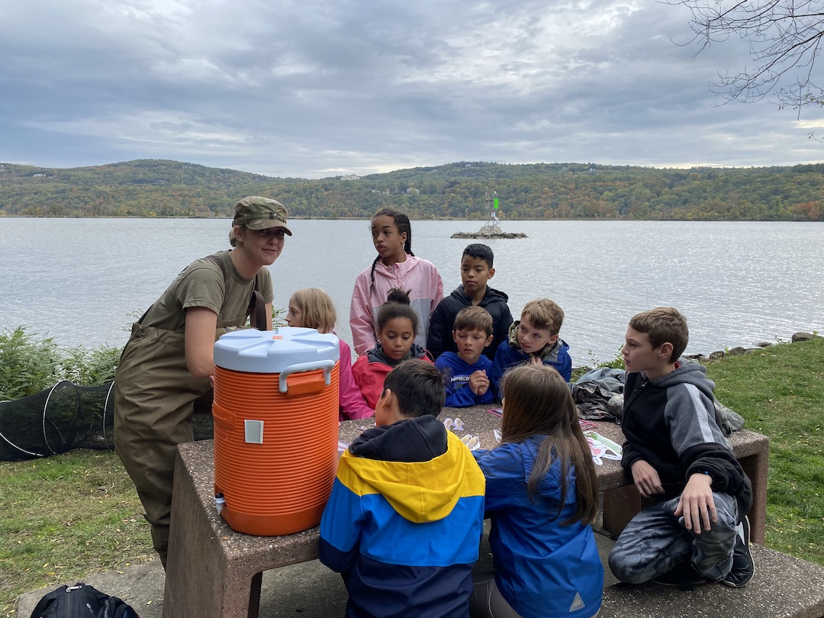

Location: USMA, West Point- Gees PT turn around
Area: At the end of Ernst Rd on the beach and rocky shore across from coast guard marker 37
Surrounding Land Use: 80% open/grassy; 15% Forested; 5% Beach
Sampling Site: Beach and RipRap
Shoreline: Sandy
Water: Choppy
Plants in area: No plants in the water
River Bottom: muddy and rocky
*NR = Not read/recorded
ITEM |  | Time |  | Reading |  |  |  | Comments
Physical
Air Temperature |  | 11:00 AM |  | 18.9° C |  |  | ^{66°F}
Wind Speed: |  | 11:00 AM |  | Anemometer  1.9 m/s |  |  | Beaufort  NR | Direction
Weather today |  | 11:00 AM |  | > 75% cloud cover |  |  | Start & Stop Rain
Weather the past 3 days: |  | The temperature has been cooler with clear skies
Tides- |  | Time |  | Rising, Falling, Unchanged |  |  | Water Height (cm)
 |  | 11:00 AM- 11:30 AM  12:00PM 12:30 PM |  | Rising  Rising  Rising  Rising |  |  | 18 cm  15 cm  7 cm  9 cm
Current- NR |  | Time |  | Cm/sec |  | Knots | North/South | Ebb/Flood/Still
Water Temperature- |  | 11:00 AM |  | 18.7°C
Turbidity- Turbidimeter (NTU) |  | 11:00 AM |  | 27.8 NTU
Chemical
Salinity- Meter/Probe |  | 11:00 AM |  | Conductivity 6.39 mS/cm
Standardized Salinity – HR Quantab |  | NR
DO – Meter/Probe |  | Time  11:00 AM |  | Temp  18.7°C |  |  | ppm DO  8.32 | % saturation  NR
pH – Meter |  | 11:00 AM |  | 7.7
Nitrates- NR
Phosphates- NR
Alkalinity- NR
Biological
Fish – Seine, fly fishing, box trap, electro-shocking |  | Number  1  11  1  1  67  6  13 |  | Name  American Eel  American Shad  Channel Catfish  Banded Killifish  Atlantic Silverside  White Perch  Striped Bass |  |  | Length of longest  -  5.3 cm  -  5.1 cm  8.5 cm  18 cm  - | Length of smallest  -  -  -  -  -  6.7 cm
Fish Totals |  | TOTAL: 100 |  | Diversity: 7
Macroinvertebrates |  | Number |  | Name |  |  | Length of longest | Length of smallest
 |  | 8 |  | Blue Crab |  |  | 15.5 cm | 2.4 cm
Macroinvertebrate Totals |  | TOTAL: 8 |  | Diversity: 1
Sediment Core - NA
Length | H2S smell |  | Oxid Top |  | Oil |  | Grain Size | Other Features
Boats-NR
 | Time |  | Name |  | Color |  | North/Southbound | Light/Loaded
Commercial
Residential

